**Assignment**

**Group Members:-**

* Hanzla Khan FA21-BCS-016
* Hassan Ali Siddiqui FA21-BCS-037

**Abstract of Previous Documentation:-**

Our program is a management system for a local fast food center where the owner will have to login with correct username and password to access the system. Once he/she have logged in, a menu will appear with different fast food items. The owner will be able to take the order from a user by adding items using buttons on the food items. An order number will be generated once the order has been taken totally.

The menu would consist of different food items with their price and the major ingredients used in them. Furthermore, the owner will be able to login only if he/she have an already existing account with valid username and password. If not, then they will be able to create a new account by signing up through the sign up button. We’ll try to make it as user friendly as possible.

There will also be a rating review section where the customers will be able to give their reviews about the fast food center’s staff, services and food out of 5 stars by giving their name, phone numbers and e-mails.

**Outcomes:-**

The name of the fast food company is Java Eats. The program first shows a login page. If a person does not have an account already, then he can make a new one by simply signing in.

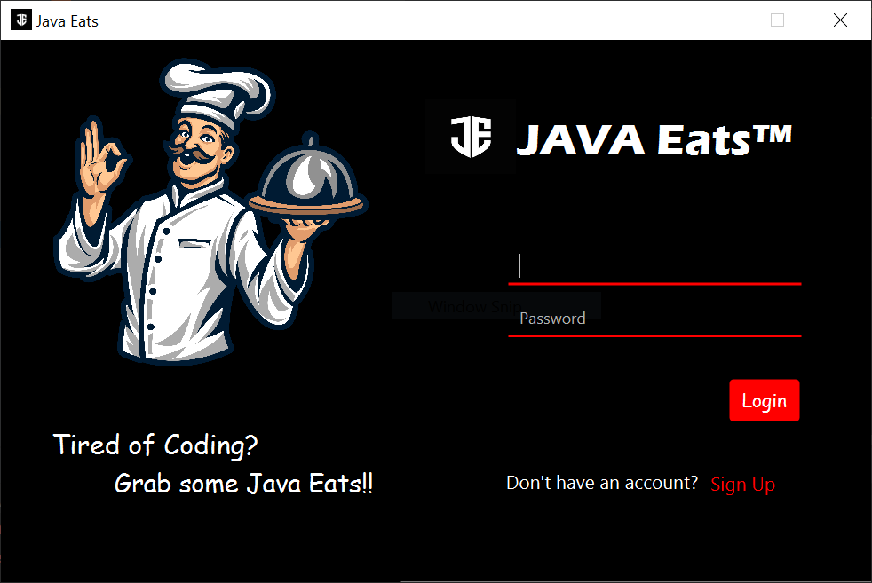

As you can see that there is a sign up prompt at the bottom right of the window. After signing in, the program will take you back to the login page. Now a person has to simply enter his email address and password to successfully login. The user details are also stored in a file so that he can come back and login any time later and don’t have to make new accounts. Also, if the person enters the email without a proper syntax i.e., without @ sign, an error message will show.

After logging in, a welcome screen will appear.

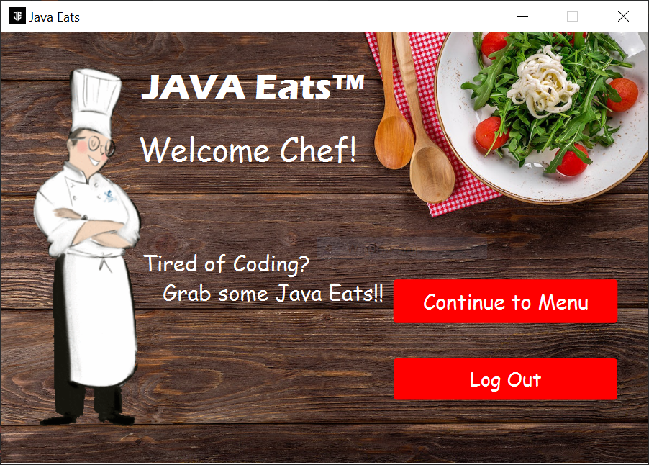

A person has now the option to log out and go on the login page and also to go and see the menu.

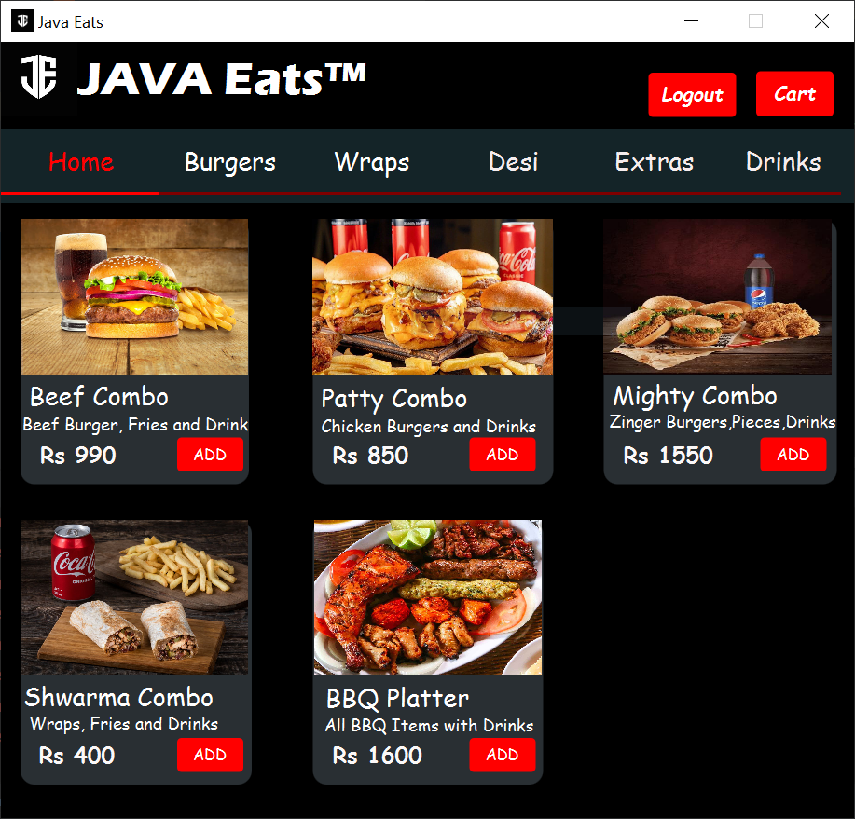

The person can simply add food items of his/her choice by clicking on the add button. The items will go and store in the cart at the top right corner of the screen. Moreover, the cart will also show the list of items and their grand total. At the end, there will be an option to checkout.

If a person adds any of the item from the add button, the desired food item will be added to cart. The user can also select a specific item more than one times and the quantity will increase, also increasing the corresponding price. The price will be then totaled or summed and a grand total of the order will show on the screen.

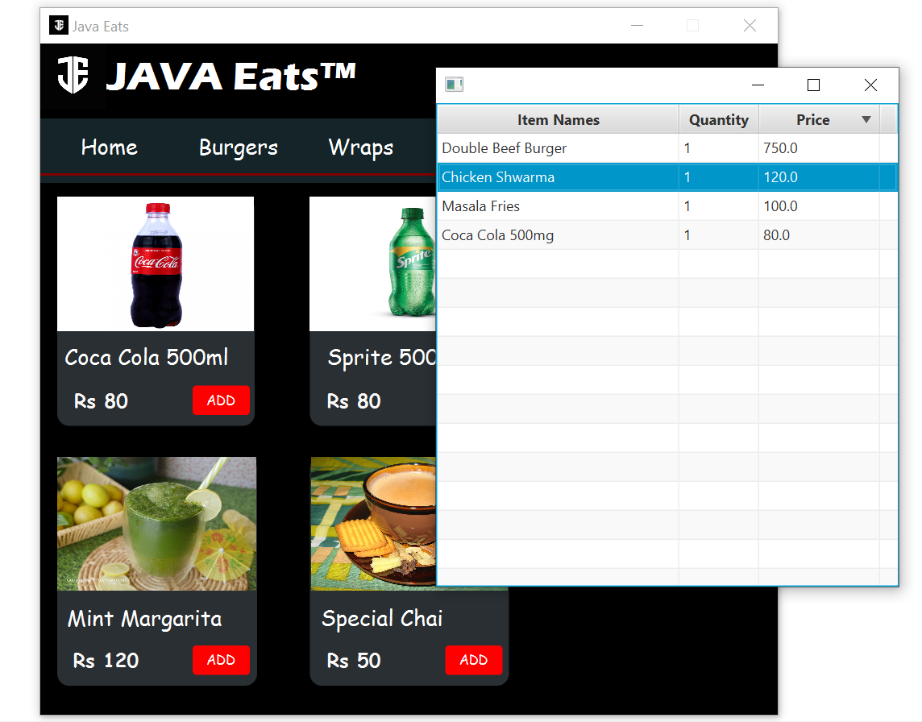

This time we added a few more scenes containing the cart and payment options with promo code and some other stuff.

